The Unreliability of the Alexandrian ManuscriptsSinaiticus and Vaticanus are among the worst manuscripts known
Luke Mounsey
July 24, 2009
Manuscript Evidence
Print

Bible scholarship of the past 150 years has placed much attention on a very small number of manuscripts. While there are over 5000 known New Testament manuscripts, attention has been placed on less than ten. Of these, Codex Sinaiticus and Codex Vaticanus have been exalted as the “oldest and best” manuscripts. The oldest claim has been disproved elsewhere. This document will focus on the nature of these two favored manuscripts. Sinaiticus has been recently made available to all on the internet by the Codex Sinaiticus Project, with the mainstream media and general Christians fawning over this “world’s oldest Bible.” This manuscript, in conjunction with Codex Vaticanus, form the basis for most modern Bible translations. However, these two manuscripts differ substantially from the text of the bulk of the manuscripts. Thus, the public needs to know the truth about these manuscripts.
Contrary to what has been taught in most seminaries, these two manuscripts are worthless, and hopelessly corrupt. Dean John Burgon, a highly respected Bible scholar of the mid to late 1800’s, wrote of these manuscripts, “The impurity of the Texts exhibited by Codices B and Aleph [Vaticanus and Sinaiticus] is not a matter of opinion but a matter of fact.”1 These documents are both of dubious origin. It has been speculated by some scholars that one or both were produced by Eusebius of Caesarea on orders of Emperor Constantine2. If this is true, then these manuscripts are linked to Eusibus’s teacher Origen of Alexandria, both known for interpreting Scripture allegorically as opposed to literally. Scholars have designated these manuscripts as Alexandrian, linking them with Alexandria, Egypt, the region responsible for early heresies such as Gnosticism and Arianism. Both are dated in the mid to late fourth century.
Vaticanus is the sole property of the Vatican; it has been a part of the Vatican library since at least 1475. It’s history previous is unknown. It was written by three scribes, and has been corrected by at least two more3. Vaticanus adds to the Old Testament the apocryphal books of Baruch, Wisdom, Ecclesiasticus, Judith, Tobit, and the Epistle of Jeremiah. Dean Burgon describes the poor workmanship of Vaticanus:
Codex B [Vaticanus] comes to us without a history: without recommendation of any kind, except that of its antiquity. It bears traces of careless transcription in every page. The mistakes which the original transcriber made are of perpetual recurrence.4
The New Westminster Dictionary of the Bible concurs, “It should be noted, however, that there is no prominent Biblical MS. in which there occur such gross cases of misspelling, faulty grammar, and omission, as in B [Vaticanus].”5 Vaticanus omits Mark 16:9-20, yet there is a significant blank space here for these verses.6 Sinaiticus also lacks these verses, but has a blank space for them.7 These two manuscripts are the only Greek manuscripts that omit these verses!
The Sinaiticus was discovered by Constantine Tischendorf in the Greek Orthodox Monastery of St. Catherine, on the Sinai peninsula. Monasteries are known for exceptional libraries, and scholars would often visit to conduct research. St. Catherine’s is no exception. From the monastery’s website:
When Egeria visited the Sinai around the year 380, she wrote approvingly of the way the monks read to her the scriptural accounts concerning the various events that had taken place there. Thus we can speak of manuscripts at Sinai in the fourth century. It is written of Saint John Climacus that, while living as a hermit, he spent much time in prayer and in the copying of books. This is evidence of manuscript production at Sinai in the sixth century. The library at the Holy Monastery of Sinai is thus the inheritor of texts and of traditions that date to the earliest years of a monastic presence in the Sinai. In earlier times, manuscripts were kept in three different places: in the north wall of the monastery, in the vicinity of the church, and in a central location where the texts were accessible.8
This monastery has a library full of old manuscripts. One would then assume that Tischendorf found the prized Sinaiticus one a library shelf, hidden among other manuscripts. Well, this is not exactly the case. He found it in a trash can, waiting to be burnt! Sound incredible? Tischendorf gives his personal testimony:
It was at the foot of Mount Sinai, in the Convent of St. Catherine, that I discovered the pearl of all my researches. In visiting the library of the monastery, in the month of May, 1844, I perceived in the middle of the great hall a large and wide basket full of old parchments; and the librarian, who was a man of information, told me that two heaps of papers like these, mouldered by time, had been already committed to the flames. What was my surprise to find amid this heap of papers a considerable number of sheets of a copy of the Old Testament in Greek, which seemed to me to be one of the most ancient that I had ever seen.9
Why would the monks of St. Catherine’s thrown out such a valuable manuscript? Perhaps because of it’s low quality transcription and it’s “heavily corrected text.”10 Concerning it’s sloppy penmanship, Burgon writes, “On many occasions, 10, 20, 30, 40 words are dropped through very carelessness.11” His colleague, Frederick H. Scrivener, goes into detail:
Letters and words, even whole sentences, are frequently written twice over, or begun and immediately canceled: while that gross blunder technically known as Homoeoteleuton…whereby a clause is omitted because it happens to end in the same words as the clause preceding, occurs no less than 115 times in the New Testament…Tregelles has freely pronounced that “the state of the text, as proceeding from the first scribe, may be regarded as very rough.”12
Sinaiticus has also been corrected by “…at least ten revisers between the IVth and XIIth centuries…”13 The Codex Sinaiticus Project readily admits:
No other early manuscript of the Christian Bible has been so extensively corrected. A glance at the transcription will show just how common these corrections are. They are especially frequent in the Septuagint portion. They range in date from those made by the original scribes in the fourth century to ones made in the twelfth century. They range from the alteration of a single letter to the insertion of whole sentences. 14
The figure below gives an example of Sinaiticus’ many corrections.
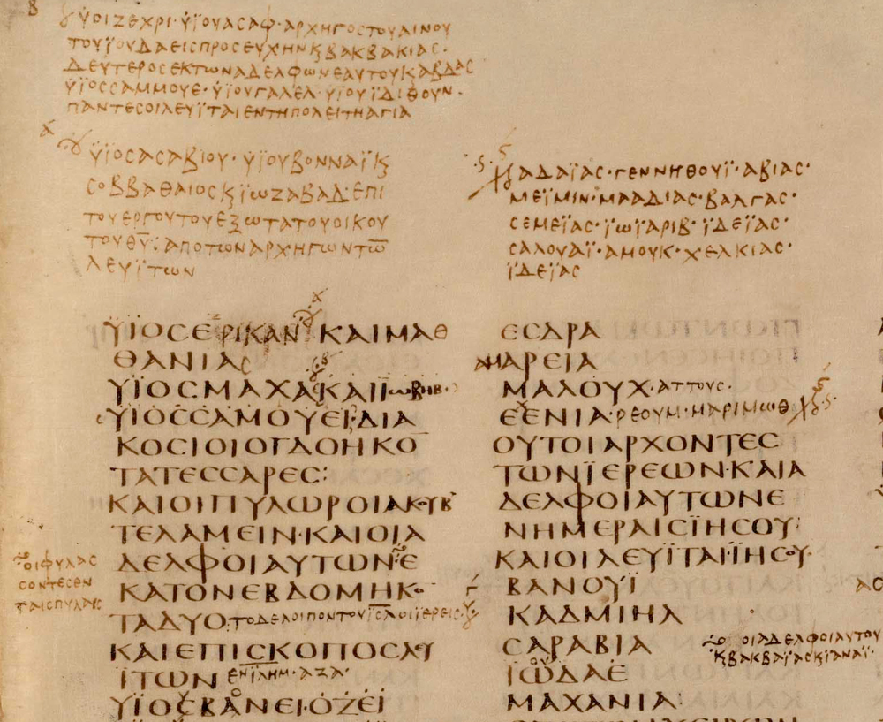
Example of Sinaiticus Corrections15
As you can see, it looks like a much-corrected rough draft. Which is the Word of God, the original text, one of the many corrections, or none of the above? Sinaiticus also includes spurious, uninspired, apocryphal books, including 2 Esdras,Tobit, Judith, 1 & 4 Maccabees, Wisdom and Sirach in the Old Testament. In the New Testament, the Epistle of Barnabas and the Shepherd of Hermas are added. New lay interest in this manuscript may be intended to create demand for an English translation of it. An 1861 translation of Sinaiticus’s New Testament has been placed online, including the Epistle of Barnabas and the Shepherd of Hermas.16 These two false writings (Epistle of Barnabas and Shepherd of Hermas) promote New Age and Satanism17. Is a resurgence in public interest in Sinaiticus and Vaticanus intended to bring acceptance of heretical works like these into Christian circles?
As for the text of these two manuscripts, it is notably an inferior text (when one is able to determine the true text in the light of all the corrections). Scholar Dean Burgon writes,
As for the origin of these two curiosities, it can perforce only be divined from their contents. That they exhibit fabricated Texts in demonstrable. No amount of honest copying,-persevered in for any number of centuries, -could by possibility have resulted in two such documents. Separated from one another in actual date by 50, perhaps by 100 years, they must needs have branched off from a common corrupt ancestor, and straightway become exposed continuously to fresh depraving influences. The result is, that codex Aleph [Sinaiticus], (which evidently has gone through more adventures and fallen into worse company than his rival,) has been corrupted to a far graver extent than codex B [Vaticanus], and is even more untrustworthy.18
Why would one of the top Bible scholars of his day make such remarks of manuscripts considered the “oldest and best” by others? Burgon had personally examined these two manuscripts, and noted that their text differed greatly form that of 95% of all manuscripts. When examining the Gospels as found in Vaticanus, Burgon found 7578 deviations from the majority, with 2370 of them being serious. In the Gospels of Sinaiticus, he found 8972 deviations, with 3392 serious ones.19 He also checked these manuscripts for particular readings, or readings that are found ONLY in that manuscript. In the Gospels alone, Vaticanus has 197 particular readings, while Sinaiticus has 443.20 A particular reading signifies one that is most definitely false. Manuscripts repeatedly proven to have incorrect readings loose respectability. Thus, manuscripts boasting significant numbers of particular readings cannot be relied upon.
These two manuscript witnesses constantly disagree with the majority of the manuscript evidence, showing them to be suspect witnesses. The Ten Commandments prohibit false testimony (Ex 20:16). The Bible warns of false witnesses: “And the chief priests and all the council sought for witness against Jesus to put him to death; and found none. For many bare false witness against him, but their witness agreed not together.” (Mark 14:55-56). The telling sign of false witnesses is a disagreement in their testimony. It will be seen that Sinaiticus and Vaticanus do not pass the false witness test. While disagreeing with the majority text, they also heavily disagree among each other. Burgon observed: “…they render inconsistent testimony in every verse…”21 and “…it is easier to find two consecutive verses in which the two MSS. differ the one from the other, than two consecutive verses in which they entirely agree…”22
Herman Hoskier did a full collation of these two manuscripts in the Gospels, and counted the following disagreements:
Table I: Disagreements between Sinaiticus and Vaticanus23
Matthew | 656
Mark | 567
Luke | 791
John | 1022
TOTAL | 3036

Therefore, Sinaiticus and Vaticanus are worthless manuscripts. They display horrible penmanship, and have been subject to many correctors. They disagree with the vast majority of manuscript evidence, and even among each other. They are false witnesses of the Word of God. The text found therein is not the preserved Word of God, because it hasn’t been preserved. If it was the true Word of God, it would have been readily available to all generations. Burgon explains,
I am utterly unable to believe, in short, that God’s promise [of preservation] has so entirely failed, that at the end of 1800 years much of the text of the Gospel had in point of fact to be picked by a German critic out of a waste-paper basket in the convent of St. Catherine; and that the entire text had to be remodelled after the pattern set by a couple of copies which had remained in neglect during fifteen centuries, and had probably owed their survival to that neglect; whilst hundreds of others had been thumbed to pieces, and had bequeathed their witness to copies made from them.24
These ancient MSS owe their preservation not to the providence of God, but to the neglect of man.
In these last days, Satan is doing everything in his power to prepare men for the great deception of the Antichrist. As Sinaiticus has been exalted in the public’s eye by the Codex Sinaiticus Project, I would not be surprised if Vaticanus is also exalted and placed online for all to see and venerate. These manuscripts may be the driving force to get “Protestants” to accept the Apocrypha as well as the Epistle of Barnabas and the Shepherd of Hermas, books so heretical that even the Roman Catholic Church does not accept them as Scripture. We need to be alert, and not fall for these manuscript idols. We also need to be aware that most Bible versions, other than the KJV, rely heavily on these manuscripts. The NKJV, while using the correct text, includes “alternate readings” from Sinaiticus and Vaticanus in the margin. (Such as “The oldest MSS. say…”) We need to reject these for the tried and true King James Version.

1Burgon, John William. The Revision Revised. London: John Murray, 1883, pg 315
2 T. C. Skeat, The Codex Sinaiticus, the Codex Vaticanus and Constantine. JTS 50 (1999), pp. 583–625.
3Benigni, Umberto. “Codex Vaticanus.” The Catholic Encyclopedia. Vol. 4. New York: Robert Appleton Company, 1908. 24 Jul. 2009 .
4Burgon, John William. The Last Twelve Verses of Mark. Oxford and London: James Parker and Co., 1871, pg. 73
5Gehman, Henry Snyder and John D. Davis. The New Westminster Dictionary of the Bible. Westminster Press, 1970. Pg 792
6Burgon, The Last Twelve Verses, pp 86-87
7See Burgon, The Last Twelve Verses, opening pages, for a photograph of this position in Sinaiticus
8http://www.sinaimonastery.com/en/index.php?lid=94
9von Tischendorf, Constantine. Narrative of the Discovery of the Sinaitic Manuscript, pg 23. http://rosetta.reltech.org/TC/extras/tischendorf-sinaiticus.html
10http://www.codexsinaiticus.org/en/
11Burgon, The Last Twelve Verses of Mark, pg 75
12Scrivener, Frederick Henry Ambrose. A full collation of the Codex Sinaiticus with the received text of the New
Testament. Cambridge: Deighton Bell and Co., 1864, pg xv http://books.google.com/books?id=CNmOa7HaS6EC&pg=PP23&dq=%22begun+and+immediately+cancelled%22
13Burgon, Revision Revised, pg 13
14http://www.codexsinaiticus.org/en/codex/significance.aspx
15http://www.codexsinaiticus.org/en/project/transcription.aspx
16http://www.sinaiticus.com/
17See G.A. Riplinger, New Age Bible Versions. Ararat, VA: A.V Publications Corp., 1993. pp 559-580
18Burgon, Revision Revised, pg 318
19Ibid., pp 12, 14
20Ibid., pg 14
21Ibid., pg 31
22Burgon, The Last Twelve Verses, pg 78
23Hoskier, H. C., Codex B and Its Allies, a Study and an Indictment, London, 1914, p.1.
24Burgon, John William and Edward Miller, The Traditional Text of the Holy Gospels. London: George Bell and Sons,
1896, pg 12
(Views: 43728)
Updated: January 18, 2020 — 8:20 PM
Tags: Alexandrian text, Oldest and best, Unreliable

